**Executing python scripts from the command line:**

When you open terminal, the command line will be operating from a certain folder. Files/scripts/data within that folder can be simply referred to by name, everything else must be given as a path so the computer knows how to find the file.

The command pwd will print the current working folder.

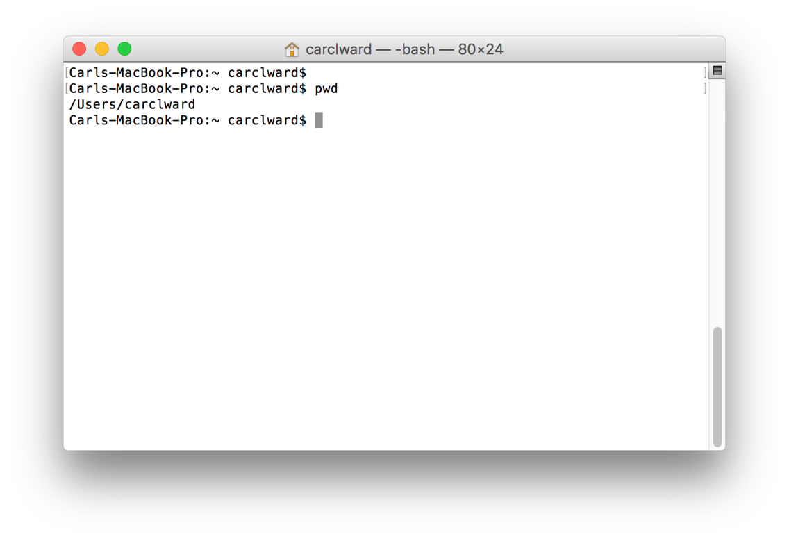

For simplicities sake, we will work in the folder with the scripts. To change directory, use the cd command follow by the path to the script folder. The path to the folder can be quickly inserted by dragging the folder into the terminal window. 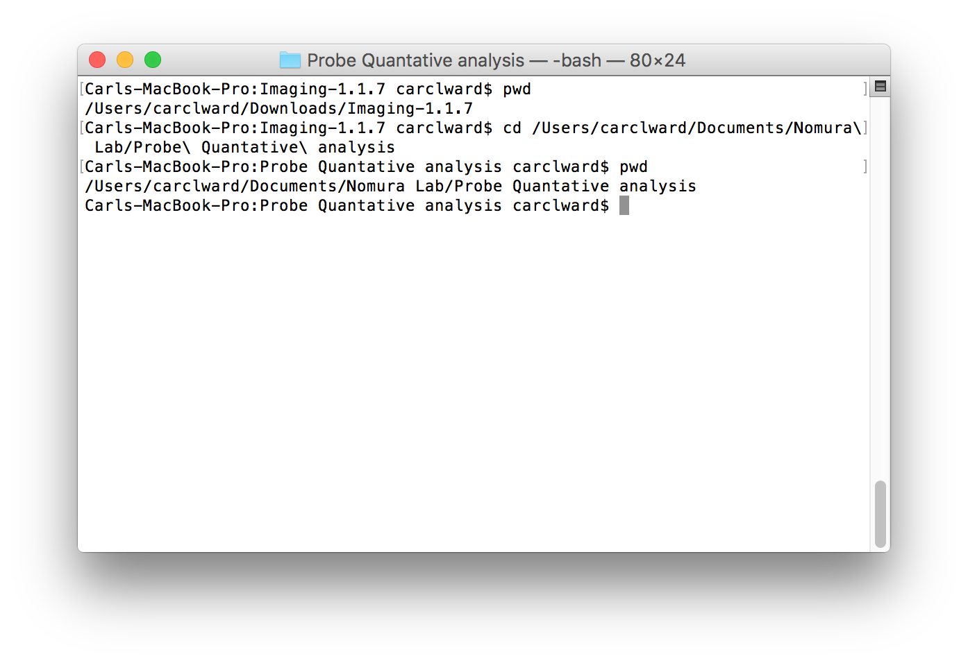

Now that we are in the directory with the scripts we can run them with the syntax:

python script_name.py in_file out_file

If the data file is in the same directory, you can type the name, using tab for auto-complete, otherwise dragging the file into terminal will paste the path.

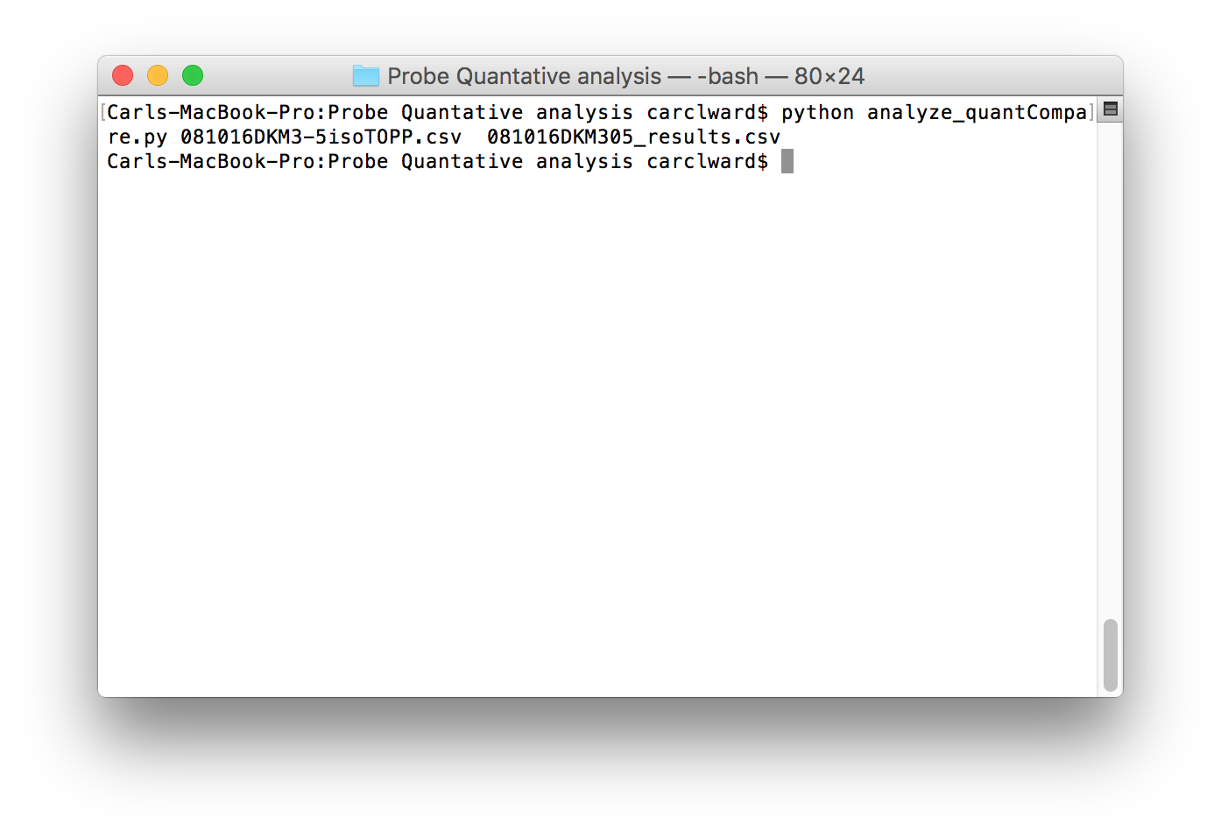

Above, the file 081016DKM3-5isoTOPP.csv was processed and 081016DKM305_results.csv was created with the averaged area ratios.

Quant Scripts:

Two scripts to collate and average quantitative proteomics data downloaded directly from IP2.

Typing python script_name.py --help gives a brief guide as well.

**analyze_quant.py**

Takes the .csv download from the peptide graph viewer, collects peptides that come from the same large peptide (ex: KGTFATLSELHC*DKL and KGTFATLSELHC*DKLHVDPENFRL would be equivalent) and averages the are ratios.

Usage:

python analyze_quant.py quant_file.csv out_file.csv -v -r

quant_file.csv: the downloaded csv file from peptide graph viewer

out_file.csv: the path/name of the file to be writer

-v: (flag) verbose output – show every peptide averaged with same area ratio

-r: (flag) reverse – write the reciprocal of the area ratio

Examples:

python analyze_quant.py 120818_DKM3-90quant.csv 120818_DKM2-90results.csv -r

(one line)

This would take the quant csv file, collect and average area ratios for peptides, take the inverse, and print it all out. By leaving off the “-r” the normal ratios would be printed

**analyze_quantCompare.py**

Takes the .csv download from the quantCompare page, collects peptides that come from the same large peptide (ex: KGTFATLSELHC*DKL and KGTFATLSELHC*DKLHVDPENFRL would be equivalent) and averages the are ratios. Only peptides that show up in > 1 runs are counted.

Usage:

python analyze_quantCompare.py quantC_file.txt out_file.csv -v -r

quantC_file.txt: the downloaded file from the quantCompare results (usually a txt)

out_file.csv: the path/name of the file to be writer

-v: (flag) verbose output – show every peptide averaged with same area ratio

-r: (flag) reverse – write the reciprocal of the area ratio

Examples:

python analyze_quant.py 120818_DKM3-90quantC.csv 120818_DKM2-90results.csv -r

(one line)

This would take the quant csv file, collect and average area ratios for peptides, take the inverse, and print it all out. By leaving off the “-r” the normal ratios would be printed